Mastering @Aspect (Spring AOP)

What is AOP (Aspect-Oriented Programming)?
Aspect-Oriented Programming (AOP) is a programming paradigm that allows you to separate cross-cutting concerns (like logging, security, transactions, exception handling) from business logic, without modifying the business classes.

Why AOP Exists ?
In real applications, some logic is needed everywhere, but does not belong anywhere.
Examples:
• Logging
• Security checks
• Transaction management
• Performance monitoring
• Exception handling
These concerns:
• Cut across multiple classes
• Get duplicated everywhere
• Pollute business logic
This causes:
- Code duplication
- Tight coupling
- Poor readability
- Hard maintenance
This problem is called Cross-Cutting Concerns Spring AOP Solves this problem.

Spring AOP
“Spring AOP is a proxy-based implementation of Aspect-Oriented Programming that allows cross-cutting concerns to be modularized and applied declaratively at runtime.”
- Proxy-based
- Runtime weaving
- Method-level interception
Spring does not modify your bytecode directly It wraps your beans with proxies.
What Spring AOP Does ?
Spring AOP says:
“Do NOT write logging, security, or monitoring code inside business classes.”
Instead:
• Keep business logic clean
• Put cross-cutting logic in separate Aspect classes
• Let Spring intercept method calls automatically
This separation is achieved using:
• Proxies
• Pointcut expressions
• Advice methods

AOP Story Flow

Without AOP (Problem State)

Class A calls Class B directly
Class B contains:
- Business logic
- Logging code
- Exception handling
- Performance tracking
➡️ Business logic and cross-cutting concerns are mixed together

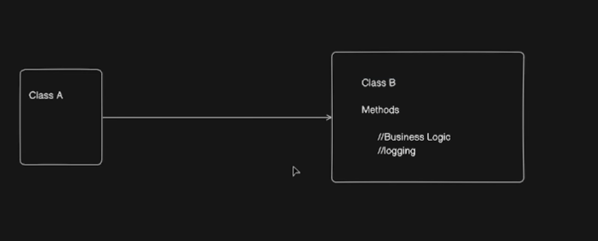
Flow:


Problems:
• Code duplication across services
• Business logic polluted
• Hard to change logging globally
• Poor maintainability

With AOP (Solution State)
AOP introduces a separate class for cross-cutting concerns.
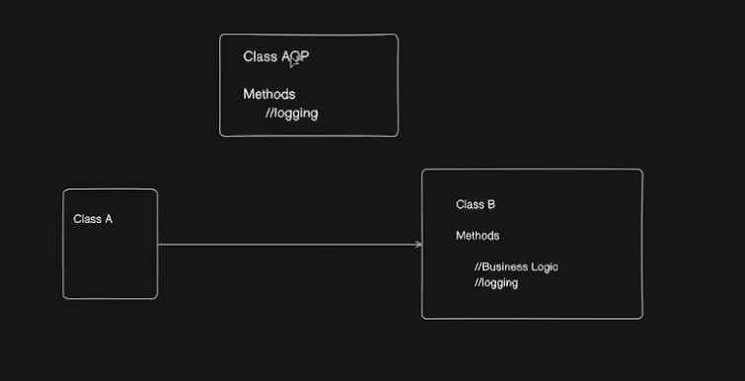
• Logging is moved to Class AOP (Aspect)
• Class B now contains only business logic
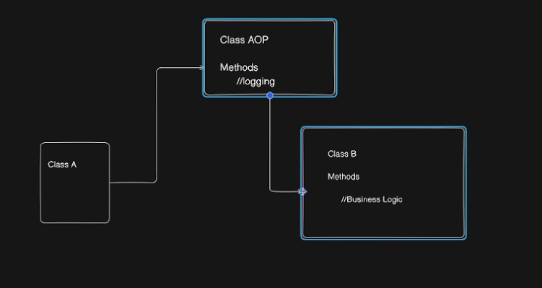
• Spring creates a proxy around Class B
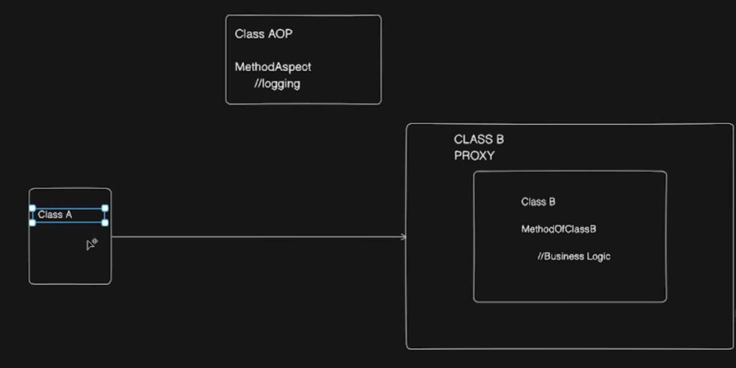
Flow:
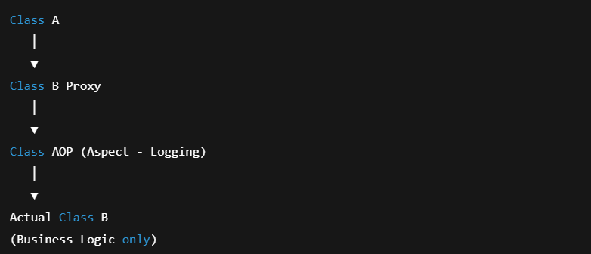
What Changed?
• Class A still thinks it is calling Class B
• In reality, the call goes to a proxy
• The proxy:
- Checks if any Aspect applies
- Executes Aspect logic (Before / After / Around)
- Calls the actual Class B
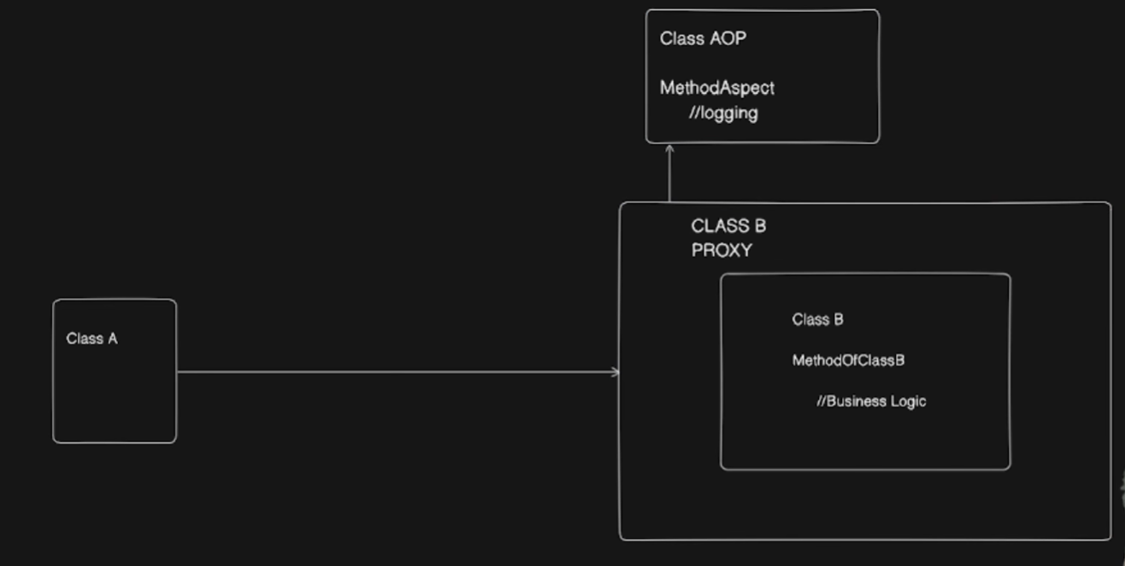
Responsibility Separation
• Class A – Caller
• Class AOP – Cross-cutting concerns (logging, exceptions, monitoring)
• Class B – Pure business logic
This separation is the core purpose of AOP.
How Spring AOP Works ?
- Spring creates the actual bean (Class B)
- Spring wraps it with a proxy
- The proxy:
• Checks if any Aspect applies (via Pointcuts)
• Executes the Advice
• Then calls the actual method
Your code never changes.
Your business class never knows AOP exists.
AOP Terminologies
🔹 Aspect
A class that contains cross-cutting logic
Example: LoggingAspect, SecurityAspect
🔹 Join Point
A point during program execution
In Spring AOP → method execution only
🔹 Advice
The action taken at a join point
Types:
- @Before
- @After
- @AfterReturning
- @AfterThrowing
- @Around
🔹 Pointcut
Expression that defines where advice applies
🔹 Target Object
The original bean being advised
🔹 AOP Proxy
The wrapper object created by Spring
🔹 Weaving
Linking aspects with target objects
(Spring does this at runtime)

AOP in Spring Boot (Application Example)
Without AOP (The Problem)
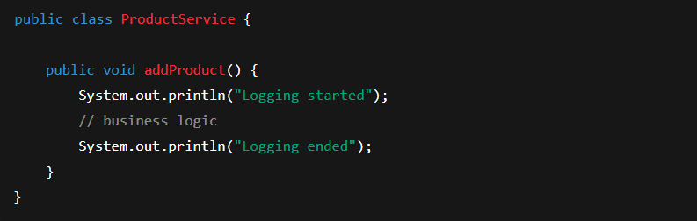
Problems:
• Logging mixed with business logic
• Code duplication
• Hard to change globally
With AOP (Clean Architecture)
Business Service (Clean)
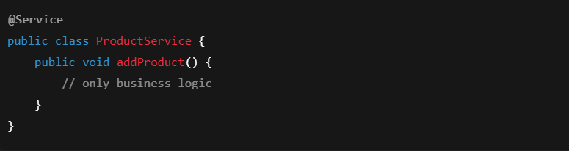
Logging Aspect
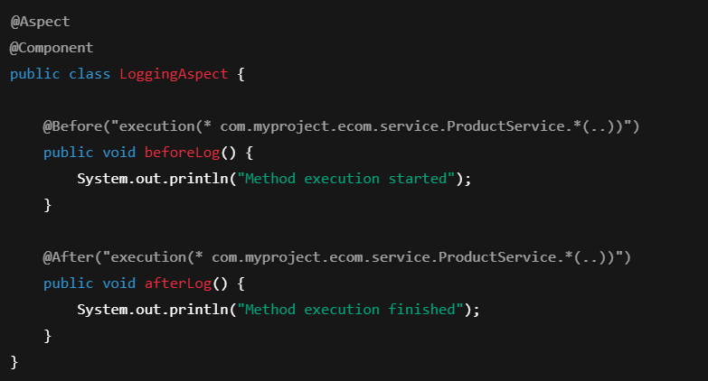
What Actually Happens Internally
Method Call Flow
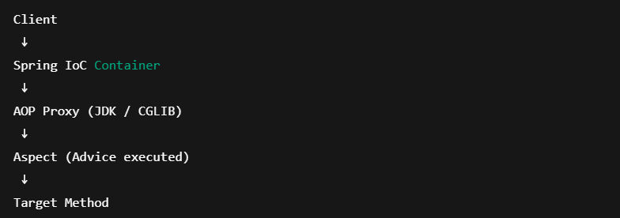
Spring AOP Advices: @Before, @After, @Around
In Spring AOP, Advice defines what action to take and when to take it relative to a method execution (Join Point).
Spring provides multiple advice types :
- @Before
- @After
- @Around

Business Class
Let’s keep the business logic clean and simple.
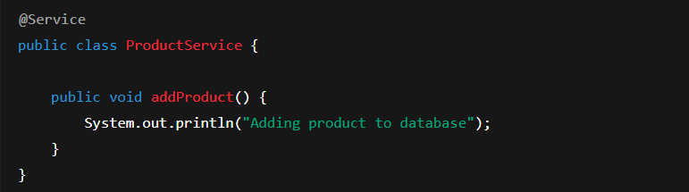No logging.
No security.
Only business logic. ✅
@Before Advice
“Run something before the method executes”

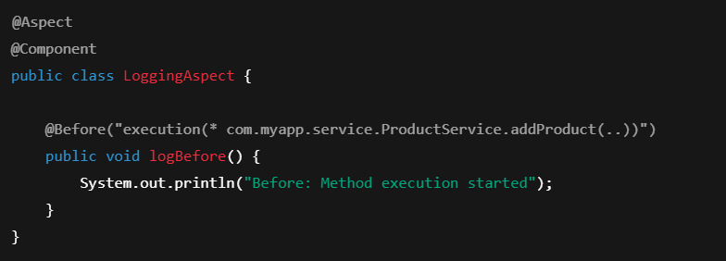
Execution Flow
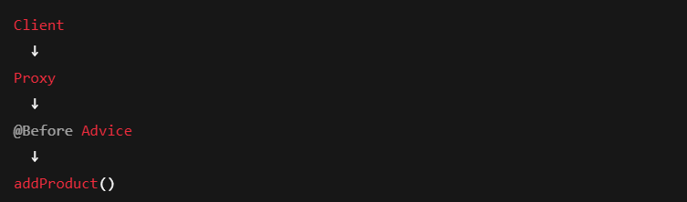
Output
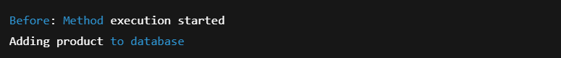

“@Before advice executes just before the target method and is commonly used for logging or validation.”

❌ Cannot stop method execution
❌ Cannot modify return value

@After Advice
“Run something after the method finishes”
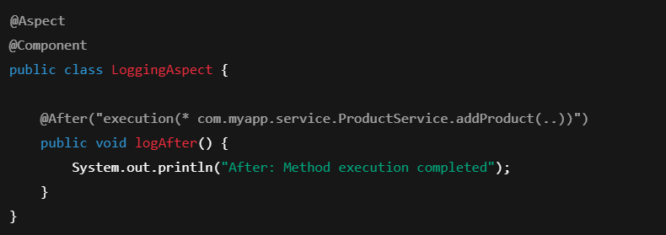
Execution Flow
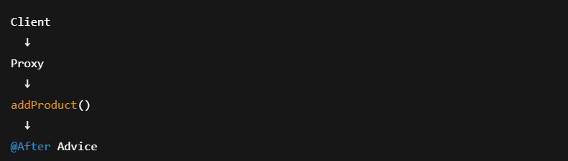
Output
Adding product to database
After: Method execution completed

“@After advice executes after the method completes, regardless of success or failure.”

When is it used?
• Cleanup
• Logging completion
• Resource release
Important Detail
✔ Runs after method execution
✔ Runs even if exception occurs
❌ Cannot access return value
@Around Advice
“Full control over the method execution”
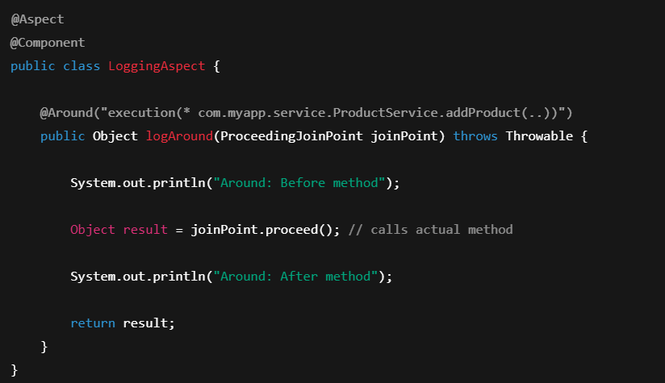
Execution Flow
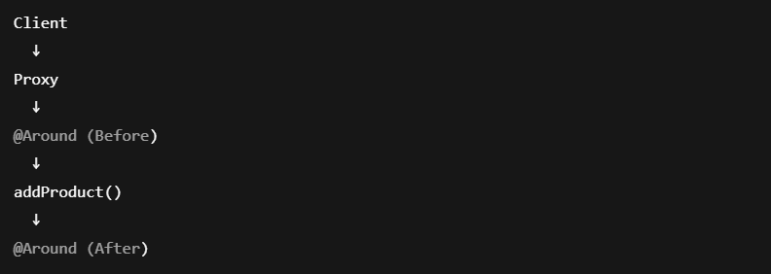
Output
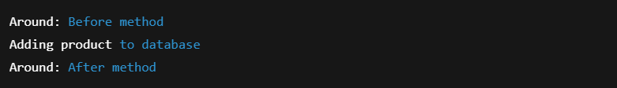

What can @Around do?
✔ Execute code before
✔ Execute code after
✔ Control method execution ✔ Modify return value
Why joinPoint.proceed() is Critical
❗ If you don’t call proceed()
➡ Business method will never execute
“@Around advice gives full control over method execution and is the only advice that can prevent a method from running.”

Comparison Table
Advice | Runs When | Can Stop Method? | Can Modify Return?
@Before | Before method | ❌ No | ❌ No
@After | After method | ❌ No | ❌ No
@Around | Before & After | ✅ Yes | ✅ Yes

How This Maps to Our Flow Diagram
Without AOP
With AOP
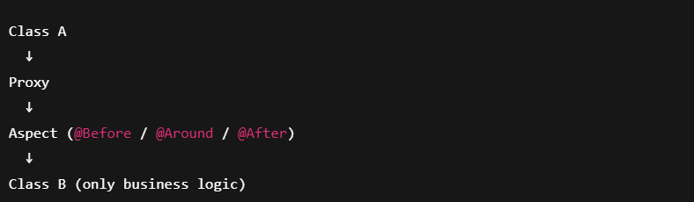

“@Before and @After add behavior around a method, but @Around controls the entire execution flow using proxies.”

Pointcut Expressions
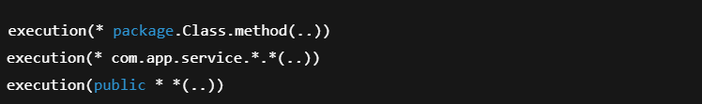

Most Asked Interview Questions
Q1. Why Spring AOP uses proxies?
Because it avoids bytecode manipulation and keeps runtime weaving lightweight.
Q2. Why only method-level join points?
Because Spring AOP is proxy-based.
Q3. Why @Around is powerful?
It controls execution flow.
Q4. Why AOP fails inside same class?
Self-invocation bypasses proxy.
Q5. JDK vs CGLIB?
Interface vs subclass proxy.

One-Page Mental Model
“Spring never touches your class directly.
It wraps it.
Intercepts calls.
Executes aspects.
Then forwards execution.”

Summary
Spring Boot starts →
IoC Container initializes →
Beans are created →
If @Aspect exists → Proxies are created →
Client calls proxy →
Aspect executes →
Business logic runs →
Response returned.
You never see it — but your system depends on it.

OOP vs AOP
Object-Oriented Programming (OOP)
Focuses on:
• Classes
• Objects
• Inheritance
• Polymorphism
OOP answers:
👉 What does this object do?
Aspect-Oriented Programming (AOP)
Focuses on:
• Behavior applied around method execution
AOP answers:
👉 What should happen before / after / around this logic?
AOP complements OOP — it does NOT replace it.

